## **Extra Credit: Company Stack Research**

* Identify 3 software or technology companies that interest you.
* Conduct research to figure out some or all of the elements of each company’s technology stack. Check job openings/job descriptions, engineering blogs, and anything else that may have information about what the company uses to write/build it’s software products.
* Record your findings in a google doc. If you can find information about why the company chose that stack, include that as well.
* Save your files and push them to GitHub with your code.



# **Saleshandy**

# Sales Automation Platform



# **Outreach**

# Outreach is a sales automation tool for SMB and enterprise organizations, which allows users to triple the number of leads they convert to appointments.



# **Yesware**

# When your sales team needs to drive more revenue through email outreach, but complex enterprise sales software is overkill — try Yesware.



# **Saleshandy**

# Sales Automation Platform

<https://www.saleshandy.com/>

<https://stackshare.io/companies/saleshandy>

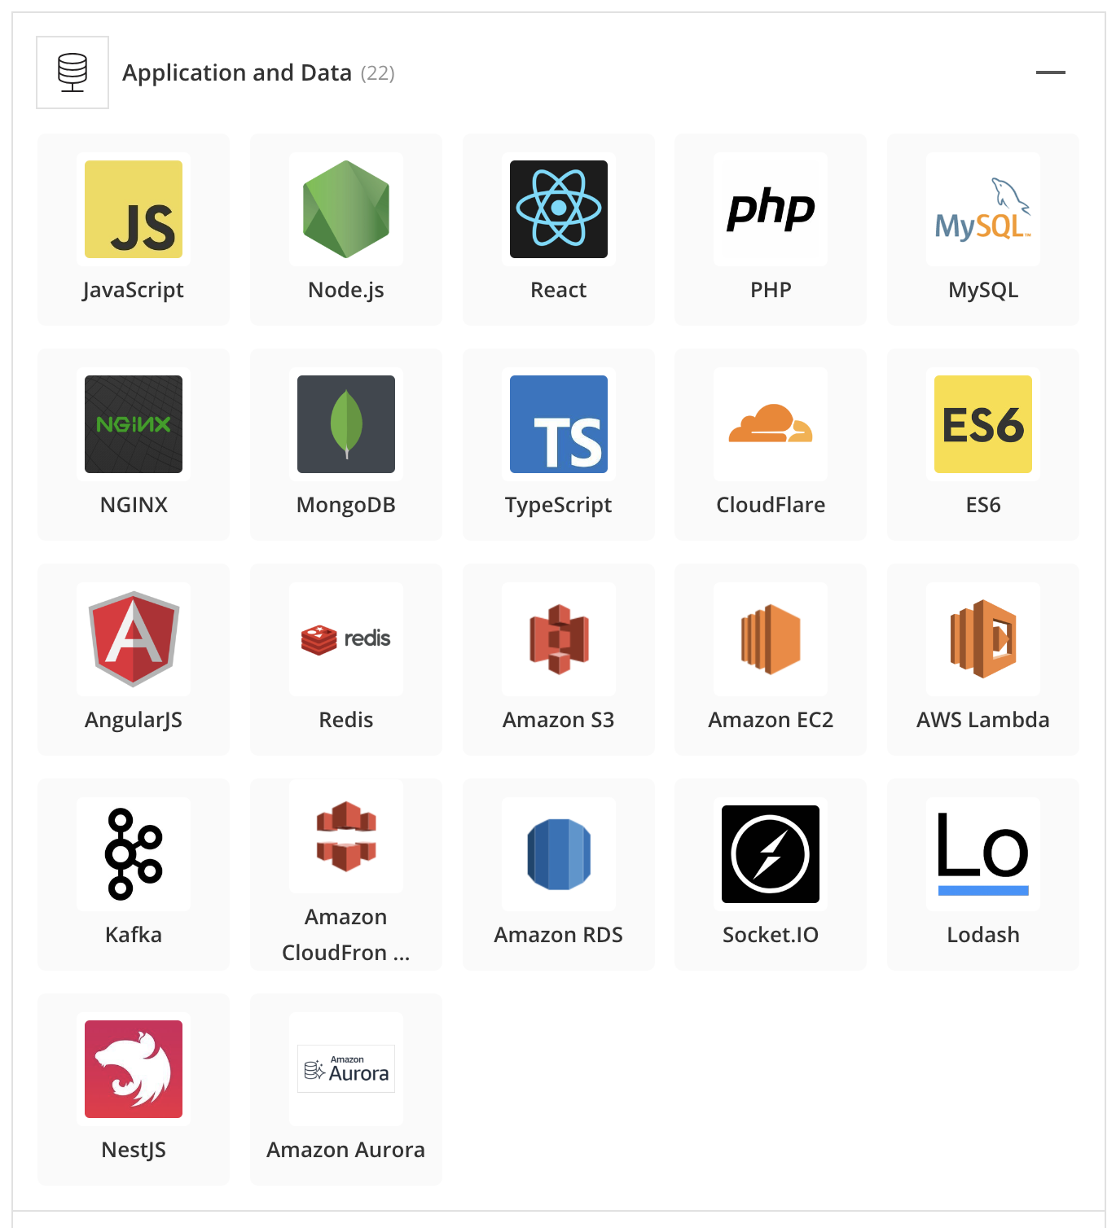

# **Information regarding job opportunities found on the company website.**

<https://ikigai.co.in/open-positions/>

Looks like they have a Node.js position that they are trying to fill, as well as a few other engineering positions.

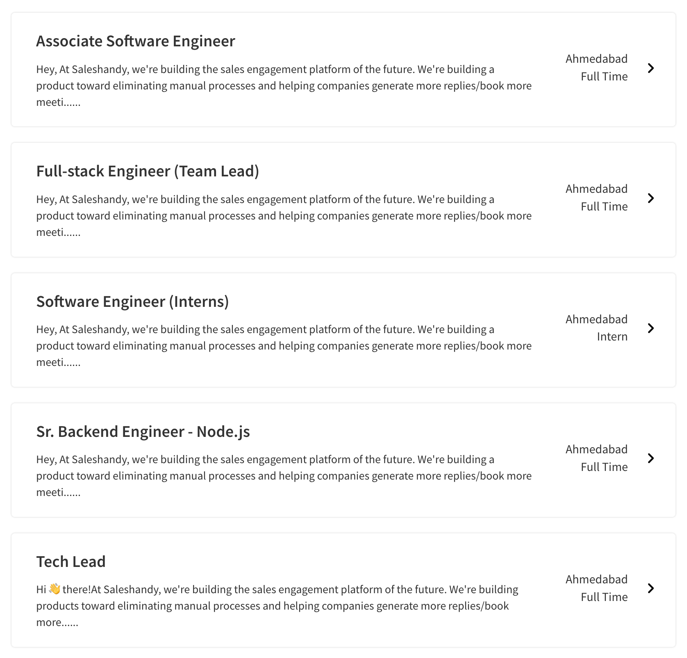



# **Outreach**

Outreach is a sales automation tool for SMB and enterprise organizations, which allows users to triple the number of leads they convert to appointments.

<https://www.outreach.io/>

<https://stackshare.io/outreach-io/outreach>

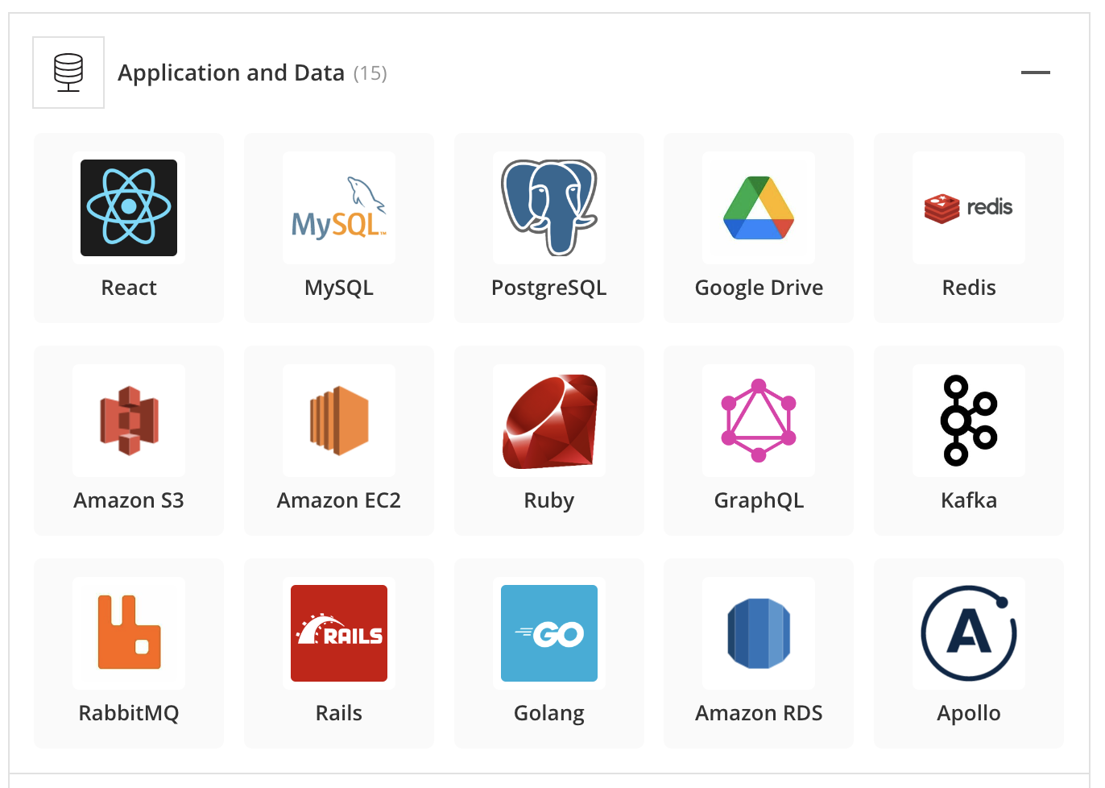

This information was retrieved from the following site:

<https://6sense.com/company/outreach/5ba66c387c866613751b323b>

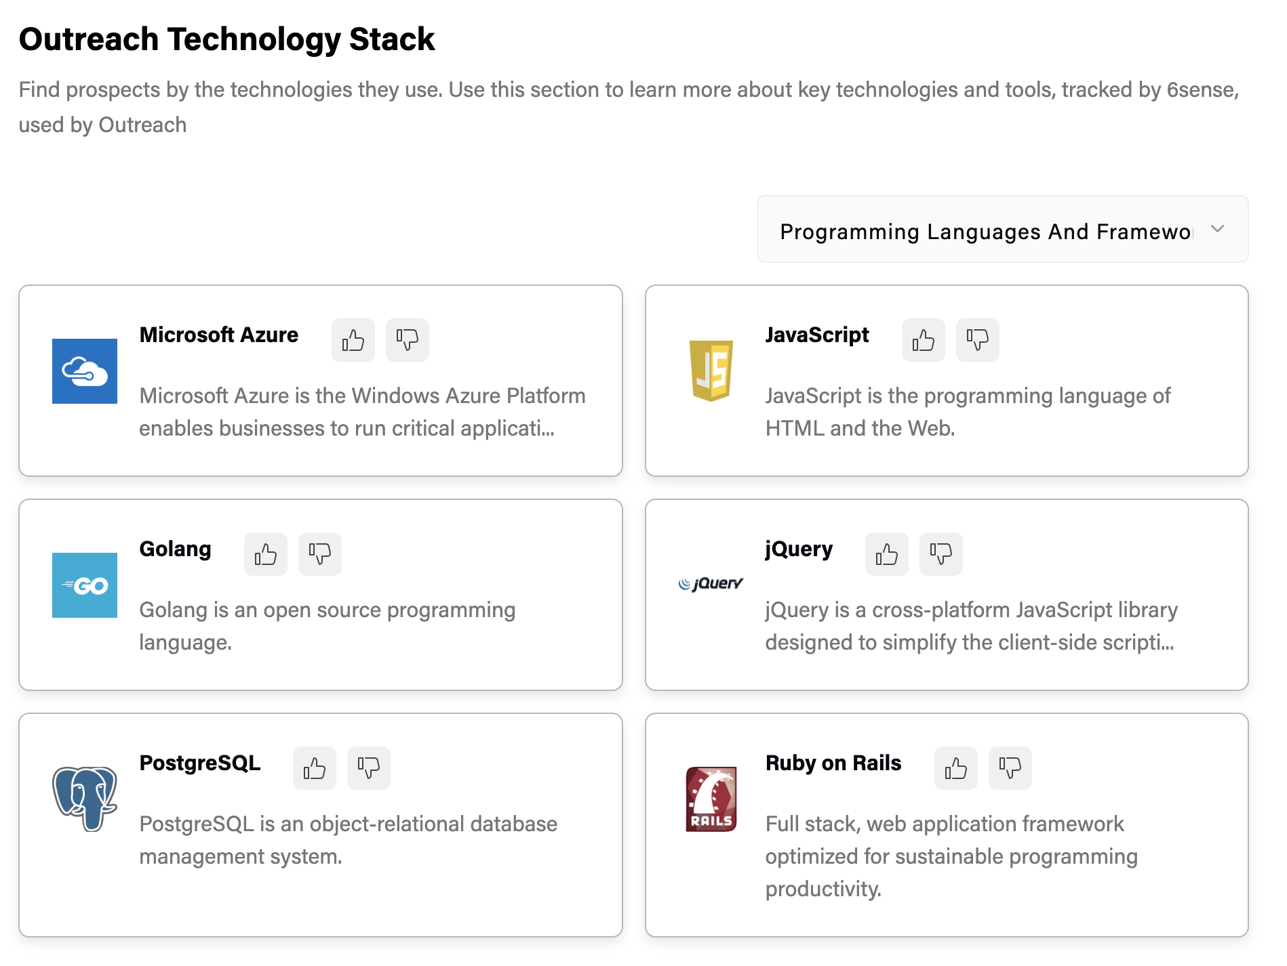



# **Yesware**

# When your sales team needs to drive more revenue through email outreach, but complex enterprise sales software is overkill — try Yesware.

<https://www.yesware.com/>

[https://stackshare.io/yesware/yeswar](https://stackshare.io/yesware/yesware)

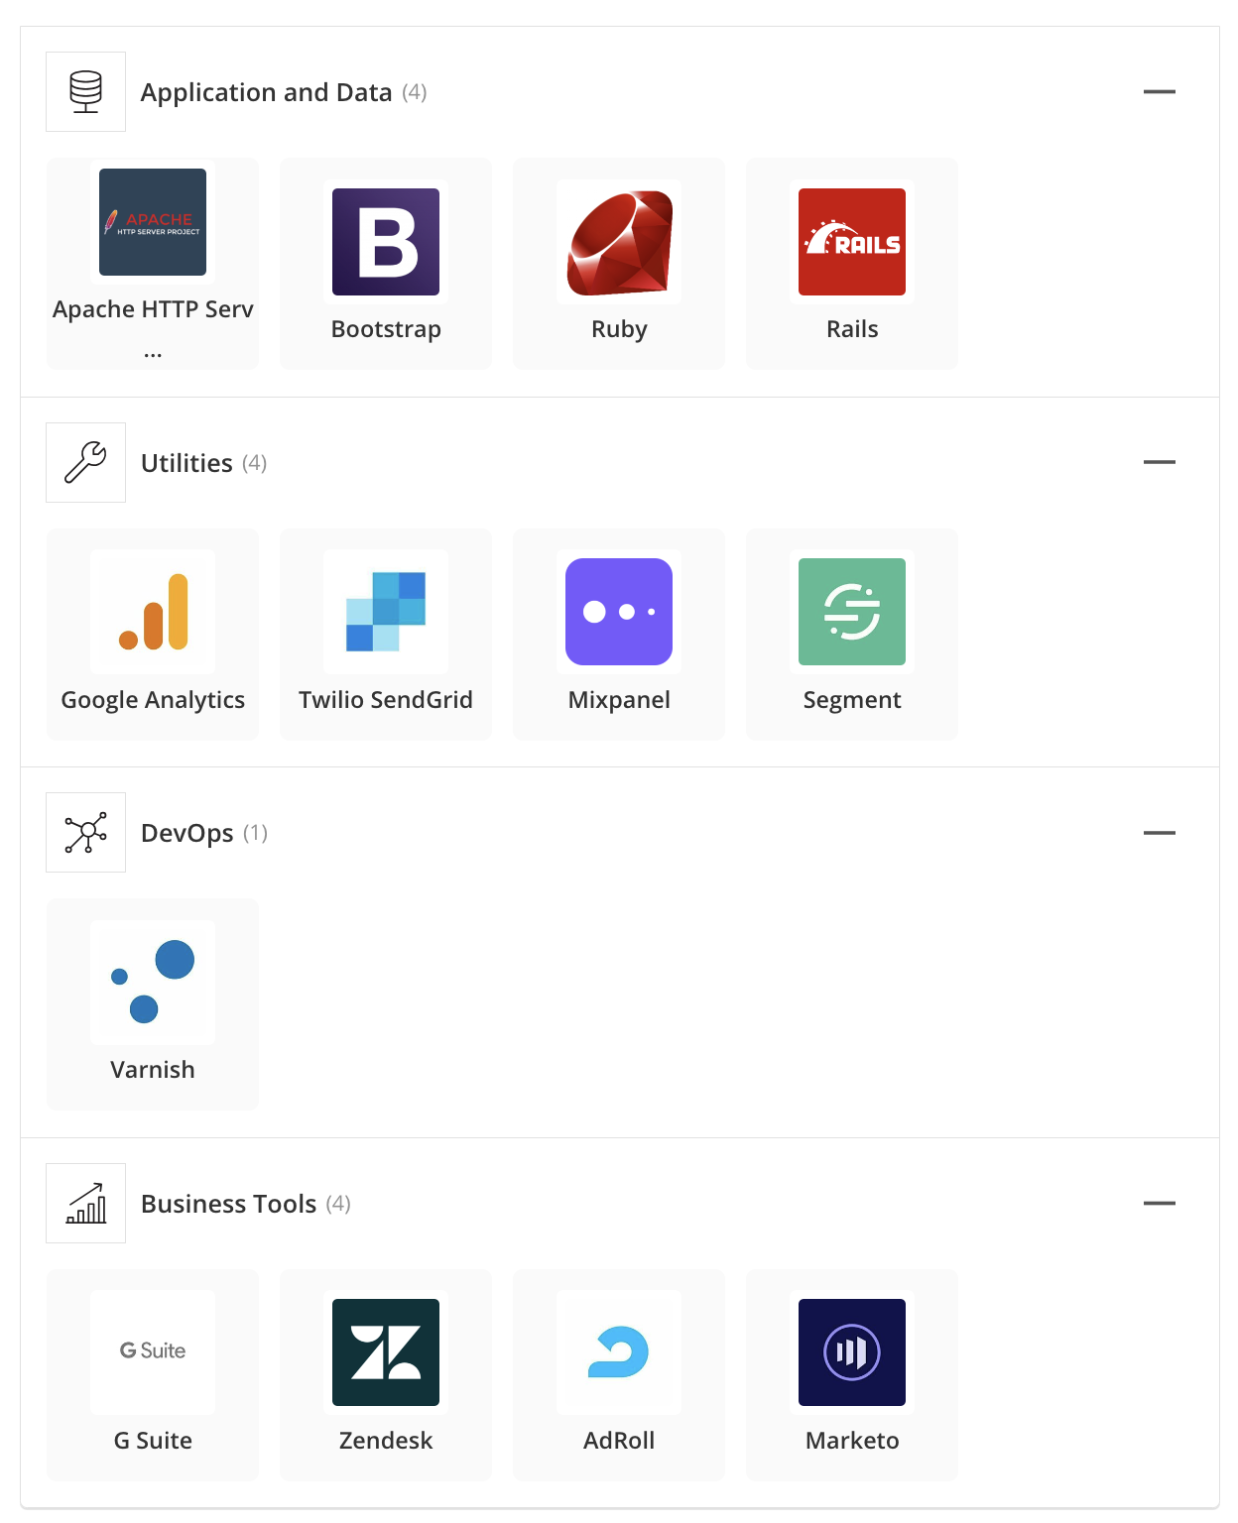

On the yesware career page i was able to find job openings for software developer positions. The following information was found.

**Technologies We Use At Yesware**

* Cloud Native Computing using Google Cloud Platform
* BigQuery, Cloud Dataflow, Cloud Pub/Sub, Google Data Studio, Cloud IAM, Cloud Storage, Cloud SQL, Cloud Spanner, Cloud Datastore, Google Maps Platform, Stackdriver, etc… We have been invited to join the Early Access Program on quite a few GCP technologies.
* Kubernetes
* GoLang, Typescript, Python, Javascript, HTML
* Angular
* Elasticsearch, MySQL, PostgreSQL
* GRPC

Here is some additional research i found interesting regarding

## Popular technology stacks used by large companies.

| Company Name | Apps & Data | DevOps | Business Tools |
| --- | --- | --- | --- |
| Netflix | Python  Node.js  React  Java  MySQL  PostgreSQL  Amazon S3  Amazon EC2  Flask  Amazon RDS  Amazon DynamoDB  Cassandra  Hadoop  Oracle  Amazon RDS for PostgreSQL  Amazon EMR  Presto  CloudBees  Pig  WinJS  Atlas-DB | GitHub  Git  Jenkins  Gradle  AWS CloudTrail  Apache Mesos  Sumo Logic  Express Gateway  LogicMonitor  Crittercism  Dynomite  Boundary  Vector | G Suite  Confluence  OneLogin  HubCommander |
| Instagram | JavaScript  Python  React  Java  NGINX  PostgreSQL  Redis  Django  GraphQL  React Native  Redux  Objective-C  Memcached  Cassandra  Gunicorn  Imutable.js  Gearman  ReasonML | Webpack  Babel  Sentry  Jest  HAProxy  Fabric  Flow (JS)  Nuclide | – |
| Facebook | React  PHP  GraphQL  Memcached  Cassandra  Flux  Tornado  Presto  Hack  Relay Framework  RocksDB  Yoga  Prepack  McRouter  Hydra Framework  Beringei | Jenkins  Datadog  Jest  Chef  Phabricator  HHVM (HipHop Virtual Machine)  Nuclide  Buck  Infer  LogDevice | Confluence  Campaign Monitor |
| Google | Python  Java  AngularJS  Android SDK  Golang  C++  Dart  guava  Material Design Lite Material Design  Preact  LevelDB | Kubernetes  Android Studio  Bazel  EarlGrey  Seesa | Gmail  G Suite  Google Meet |
| AirBnB | JavaScript  React  Java  MySQL  NGINX  Redis  Amazon S3  Amazon EC2  Sass  Ruby  Amazon CloudFront  Rails  Amazon RDS  Hadoop  Airflow  Amazon EBS  Presto  Druid  Airpal | GitHub  Webpack  New Relic  Kibana  Sentry  Amazon CloudWatch  Logstash  Vagrant  Datadog  Jest  Chef  Enzyme  Apache Mesos  SmartStack | Slack  G Suite  Asana  InVision  Campaign Monitor  React Sketch.app  Assemblage |
| Spotify | Python  Java  NGINX  PostgreSQL  Bootstrap  Amazon S3  Amazon CloudFront  Kafka  Cassandra  Hadoop  Google BigQuery  Apache Storm  Google Cloud Bigtable | Docker  New Relic  Datadog  Pingdom  TestFlight  Percy  Apache CloudStack  Helios | G Suite  AdRoll  Qualaroo  Desk.com  Blossom |
| Amazon | React  Java  MySQL  AngularJS  Amazon S3  Amazon EC2  Redux  Amazon CloudFront  Amazon RDS  Amazon DynamoDB  Amazon SQS  Amazon VPC  Perl  Amazon Redshift  Amazon ElastiCache  Amazon RDS for PostgreSQL  Amazon EBS  Amazon EMR  redux-saga  Amazon Elastic Transcoder | Amazon EC2 Container Service  Amazon CloudWatch  Jest  NightwatchJS | Amazon WorkSpaces |